

Programme | : | M.Tech Int Software Engineering | Semester | : | Fall 2026-2027
Course | : | Database Systems Lab | Code | : | IASWE206
Faculty | : | Dr. M. Premalatha | Slot | : | L31+L32

Name:A.Nathan Anthony
Regno:25MIS1113
Ex. No. 5
Date: 03-08-2026
SQL Aggregation Function and date Function

Note:
LMS Submission Format [Word File]
Regno, name
Course code, course title
Slot
Faculty Name
Question
SQL Query – Text Format (Copy Paste)
Screenshot

Ex:
Question:
create a student table with attributes regno, name, mobno and dob with appropriate datatypes and sizes

Query:
SQL> create table student_mp(regno varchar(4), sname char(10), mobno number(10), dob date);
Table created.

Screenshot:

SQL> desc student_mp
Name Null? Type
----------------------------------------- -------- ------------
REGNO VARCHAR2(4)
SNAME CHAR(10)
MOBNO NUMBER(10)
DOB DATE
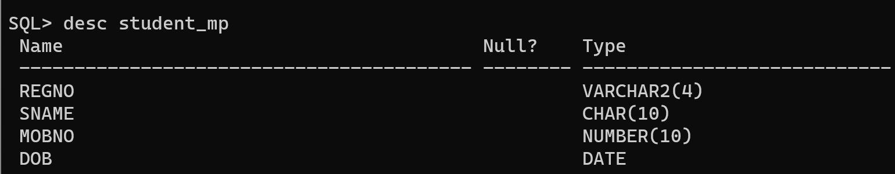

student(regno, sname, cgpa, school)
course(ccode, cname, credits)
faculty(empid, fname, designation, salary)
course_student(regno, ccode)
course_faculty(fid, ccode)

From the already created tables with key constraints of the above specified schema, write the SQL queries for the following:

- List the courses which have credits more than the average credits of all the courses.

Query:

SQL> select ccode, cname, credits from course where credits > (select avg(credits) from course);

CCODE CNAME CREDITS
---------- -------------------------------------------------- ----------
C101 DBMS 4
C103 Mechanics 4
C104 Circuits 5
C107 Physics 4

Screenshot:
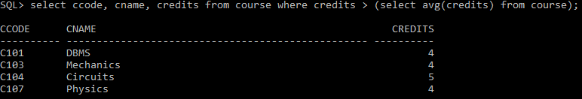
- List the total salary of the faculty for each designation

Query:
SQL> select designation, sum(salary) as total_salary from faculty group by designation;

DESIGNATION TOTAL_SALARY
------------------------------ ------------
Professor 420000
Lecturer 65000
Associate Professor 208000
Assistant Professor 75000
Screenshot:
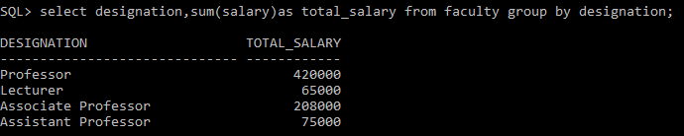
- Name the faculty who receive the highest salary

Query:
SQL> select fname, salary from faculty where salary=(select max(salary) from faculty);

FNAME SALARY
-------------------------------------------------- ----------
Joseph 160000

Screenshot:
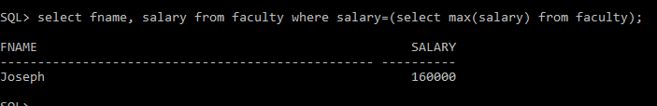

- Specify the number of students who have registered for each course

Query:

SQL>select c.ccode, c.cname, count(cs.regno) as student_count from course c left join course_student cs on c.ccode =cs.ccode
group by c.ccode, c.cname;

CCODE CNAME STUDENT_COUNT
---------- -------------------------------------------------- -------------
C103 Mechanics 1
C104 Circuits 1
C106 Management 0
C105 Surveying 1
C101 DBMS 2
C102 Java 1
C107 Physics 0

7 rows selected.

screenshot:
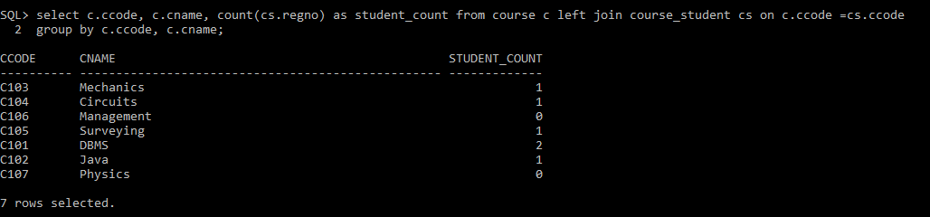
- Name the faculty members with their designation who receive the salary more than the average salary of all the faculty members

SQL> select fname, designation, salary from faculty where salary > (select avg(salary) from faculty);

FNAME
--------------------------------------------------
DESIGNATION SALARY
------------------------------ ----------
Ramesh
Professor 120000

Kiran
Professor 140000

Joseph
Professor 160000

FNAME
--------------------------------------------------
DESIGNATION SALARY
------------------------------ ----------
Priya
Associate Professor 110000

Screenshot:
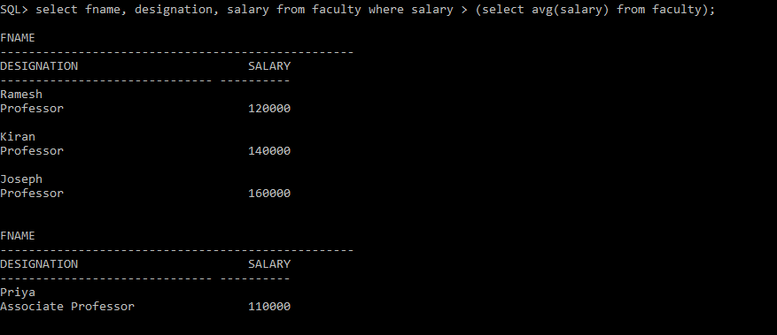
- Name the student who have scored the minimum cgpa from smec school

SQL> select regno, sname, cgpa from student where school=
'smec' and cgpa = (select min(cgpa)from student where school=
'smec');

REGNO SNAME CGPA
---------- -------------------------------------------------- ----------
104 Karthik 5.9

Screenshot:
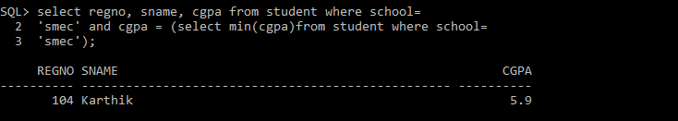
- Count the number of students who have scored more than 6 and less than 8 cgpa
SQL> select count(*) as student_count from student where cgpa>6 and cgpa<8;

STUDENT_COUNT
-------------
3
Screenshot:
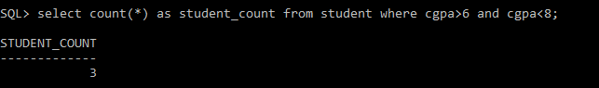
- Identify the school which has more than 3 students

SQL> select school, count(*) as student_count from student group by school having count(*) > 3;
no rows selected

screenshot:
- Specify the name regno of the students who have registered for more than 1 course.
SQL>select s.sname, s.regno from student s join course_student cs on s.regno = cs.regno group by s.sname, s.regno having count(cs.ccode) > 1;

SNAME REGNO
-------------------------------------------------- ----------
Arun 101

Screenshot:
- Add dob to student relation.

SQL> alter table student add (dob date);

Table altered.

Screenshot:
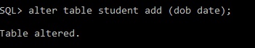
- Update the dob values for every record individually.

SQL>update student set dob = to_date('15-01-2005', 'dd-mm- yyyy')where regno = 101;

SQL>update student set dob = to_date('20-03-2004', 'dd-mm-yyyy') where regno = 102;

SQL>update student set dob = to_date('10-12-2003', 'dd-mm-yyyy')where regno = 103;

SQL>update student set dob = to_date('05-01-2012', 'dd-mm-yyyy')where regno = 104;

SQL>update student set dob = to_date('25-11-2002', 'dd-mm-yyyy')where regno = 105;

SQL>update student set dob = to_date('18-12-2002', 'dd-mm-yyyy')where regno = 106;

- List the students who are not born during “Jan” of 2012
SQL> select regno, sname, dob from student where not ( extract(month from dob) = 1 and extract(year from dob) = 2012 );

REGNO SNAME DOB
---------- -------------------------------------------------- ---------
101 Arun 15-JAN-05
102 Rahul 20-MAR-04
103 Priya 10-DEC-03
105 Divya 25-NOV-02
106 Vijay 18-DEC-02

Screenshot:
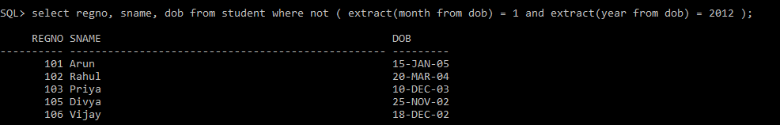
- List the students whose age is greater than 18
SQL> select regno, sname, dob from student where months_between(sysdate, dob) / 12 > 18;

REGNO SNAME DOB
---------- -------------------------------------------------- ---------
101 Arun 15-JAN-05
102 Rahul 20-MAR-04
103 Priya 10-DEC-03
105 Divya 25-NOV-02
106 Vijay 18-DEC-02

Screenshot:
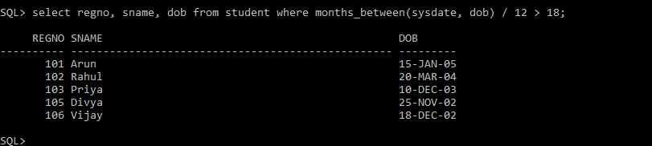

- List the first three characters of all the students’ names
SQL> select sname, substr(sname, 1, 3) as first_three_characters from student;

SNAME FIRST_THREE_
-------------------------------------------------- ------------
Arun Aru
Rahul Rah
Priya Pri
Karthik Kar
Divya Div
Vijay Vij

6 rows selected.

Screenshot:
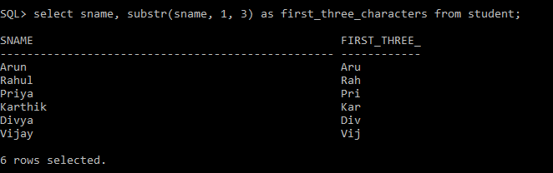
- If a student has less than 7 cgpa, increase his cgpa by 1
SQL> update student set cgpa = cgpa + 1 where cgpa < 7;

3 rows updated.

Screenshot:
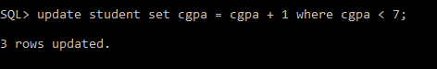
- List the students who are not born during December or November
SQL> select regno, sname, dob from student where extract(month from dob) not in (11, 12);

REGNO SNAME DOB
---------- -------------------------------------------------- ---------
101 Arun 15-JAN-05
102 Rahul 20-MAR-04
104 Karthik 05-JAN-12
Screenshot:
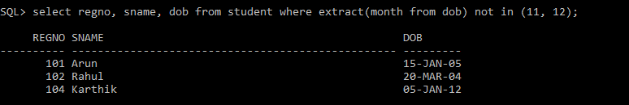
- List the name of the faculty in capital
SQL> select upper(fname) as faculty_name from faculty;

FACULTY_NAME
--------------------------------------------------
RAMESH
SURESH
MEENA
KIRAN
ANITA
JOSEPH
PRIYA

7 rows selected.

Screenshot:
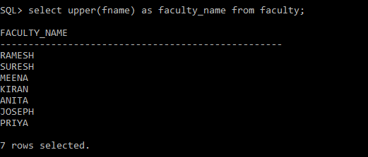
- Find the length of each designation
SQL> select designation, length(designation) as designation_length from faculty;

DESIGNATION DESIGNATION_LENGTH
------------------------------ ------------------
Professor 9
Associate Professor 19
Assistant Professor 19
Professor 9
Lecturer 8
Professor 9
Associate Professor 19

7 rows selected.

- List the course titles which has “data” in it

SQL> select ccode, cname from course where lower(cname) like '%data%';

CCODE
----------
CNAME
--------------------------------------------------------------------------------
C101
Data Structures

C102
Database Management System

C104
Data Analytics

Screenshot:
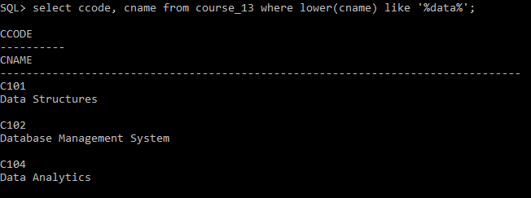
- List the students who haven’t born during Dec 2002

SQL> select regno, sname, dob from student where not ( extract(month from dob) = 12 and extract(year from dob) = 2002 );

REGNO SNAME DOB
---------- -------------------------------------------------- ---------
101 Arun 15-JAN-05
102 Rahul 20-MAR-04
103 Priya 10-DEC-03
104 Karthik 05-JAN-12
105 Divya 25-NOV-02

Screenshot:
